Project Design Phase-II
Data Flow Diagram & User Stories

Date | 13 October 2026
Team ID | SWUID2026403825
Project Name | StaffSync - Modern Human Resource Management Solution
Maximum Marks | 4 Marks

Data Flow Diagrams:
A Data Flow Diagram (DFD) illustrates how information moves through StaffSync - Modern Human Resource Management Solution. HR staff manage employee profiles and announcements; employees view their own attendance and submit leave requests; managers review team leave requests and coordinate training. The application validates each request, applies role-based permissions, and stores approved information in the MongoDB database.
Example: DFD Level 1

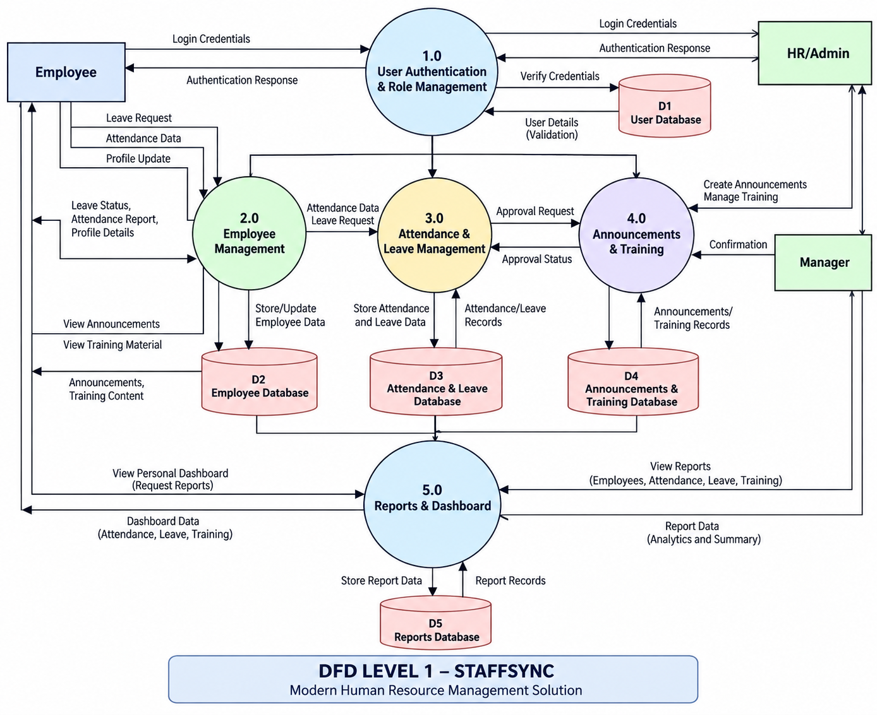

User Stories

User Story Table – StaffSync - Modern Human Resource Management Solution
User Type | Functional Requirement (Epic) | User Story / Task | Acceptance Criteria | Priority | Release
HR | Authentication & Employee Management | As an HR user, I can securely sign in and create, view, update, and manage employee profiles. | Valid credentials allow access; only authorized HR users can modify employee records. | High | Sprint-1 / Sprint-2
Employee | Attendance Management | As an employee, I can view my attendance records. | The employee sees only their own attendance records and relevant status. | High | Sprint-3
Employee | Leave Management | As an employee, I can submit a leave request and track its status. | A valid request is saved as Pending and displays its current status. | High | Sprint-3
  As a freelancer, I can apply to a job with a proposal.
Manager / HR | Leave Approval | As an authorized manager or HR user, I can approve or reject submitted leave requests. | The decision and status are saved and visible to the employee. | High | Sprint-3
HR | Announcements | As an HR user, I can publish announcements for employees. | Published announcements are visible to authorized users on their dashboard. | Medium | Sprint-2
Manager | Training Management | As a manager, I can create and update training programs. | Authorized managers can save training details and make them available to relevant employees. | Medium | Sprint-4
HR / Manager | Dashboard & Reports | As an authorized HR user or manager, I can view relevant summaries and reports. | The dashboard displays role-appropriate information without exposing unauthorized data. | Medium | Sprint-4

